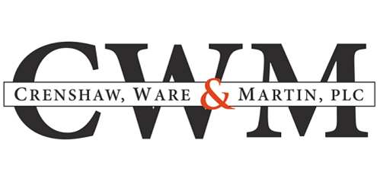

FOR IMMEDIATE RELEASE
May 9, 2022

CWM Attorneys Recognized by Virginia Super Lawyers®
Crenshaw, Ware & Martin, P.L.C. is pleased to announce that seven of its lawyers have been selected for inclusion in the 2022 list of Virginia Super Lawyers® and Rising Stars. Through a selection and evaluation process that includes peer nominations, independent research and third-party validation of professional accomplishments, Virginia Super Lawyers® recognizes attorneys who have distinguished themselves in their legal practice. The attorneys recognized in 2022 are:

Virginia Super Lawyers
Steven L. Brinker – Business/Corporation
James L. Chapman, IV – Transportation/Maritime
Darius K. Davenport – State/Local/Municipal
Donald C. Schultz (Top in Virginia) - Creditor Debtor Rights
W. Ryan Snow – Business Litigation

Virginia Rising Stars
C. Wiley Grandy – Business Litigation
David C. Hartnett – Business Litigation

For additional information, contact:
Armond Joyner
Crenshaw, Ware & Martin, P.L.C.
150 W. Main Street, Suite 1500
Norfolk, VA 23510
(757) 623-3000
ajoyner@cwm-law.com
www.cwm-law.com

